**Access Modifiers in Java:**

The access modifiers in Java specifies the accessibility or scope of a field, method, constructor, or class. We can change the access level of fields, constructors, methods, and class by applying the access modifier on it

There are four types of Java access modifiers:

**Private**: The access level of a private modifier is only within the class. It cannot be accessed from outside the class.

**Default**: The access level of a default modifier is only within the package. It cannot be accessed from outside the package. If you do not specify any access level, it will be the default.

**Protected**: The access level of a protected modifier is within the package and outside the package through child class. If you do not make the child class, it cannot be accessed from outside the package.

**Public**: The access level of a public modifier is everywhere. It can be accessed from within the class, outside the class, within the package and outside the package.

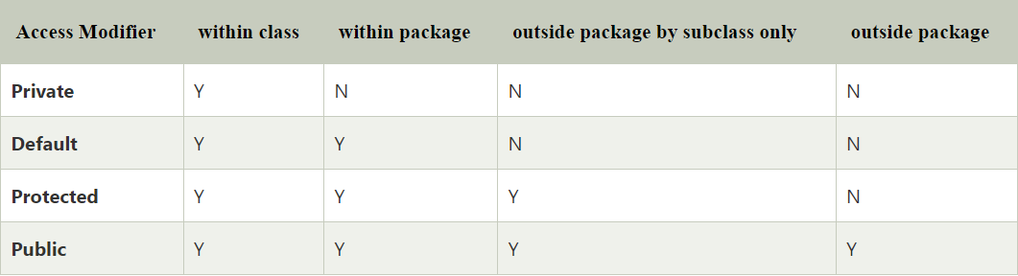

1. **Private :**

**Role of Private Constructor:**

If you make any class constructor private, you cannot create the instance of that class from outside the class.

**Note**: A class cannot be private or protected except nested class.

1. **Default:**

1. **Protected:**

The protected access modifier can be applied on the data member, method and constructor. It can't be applied on the class.

1. **Public:**

**Java Access Modifiers with Method Overriding:**

